Creating a Discipline Referral
- Log in to Aspen and scroll down to the Tasks widget. Click Initiate.
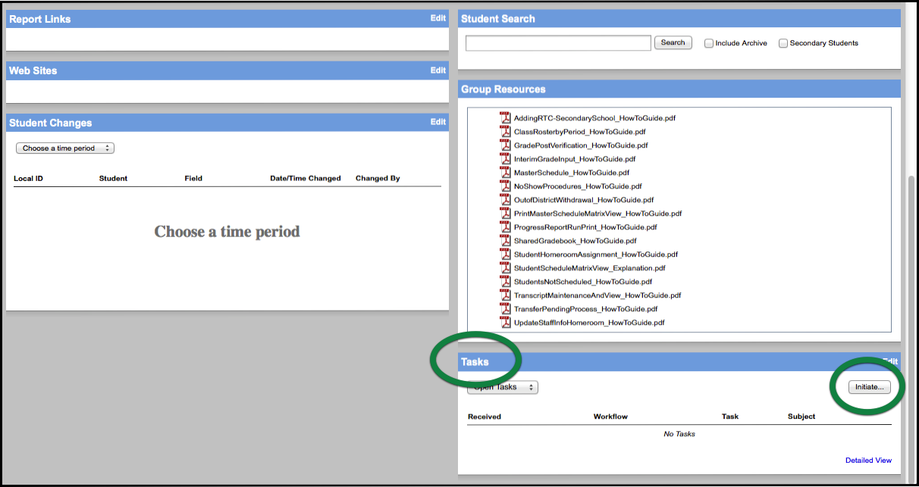

- A new window will appear. Conduct Referral and the current date should be inserted by default. Click the button to the left of Select. Click Next.
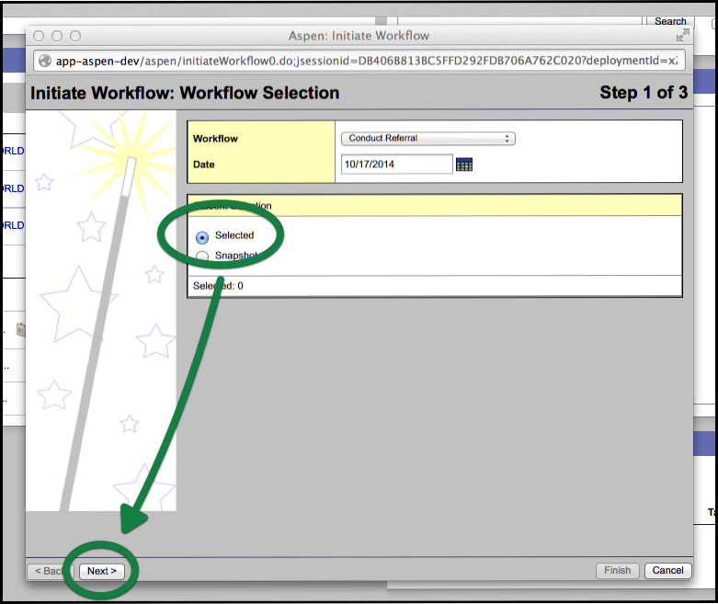

- Select the checkbox next to the name of the student who committed the offense. Click OK.
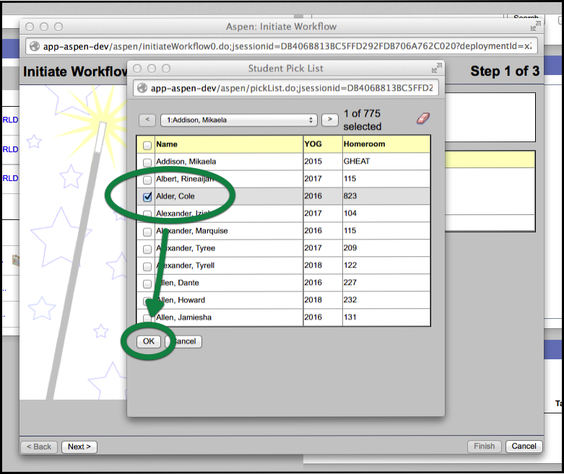

- The Student Pick List will disappear and you will see that you have selected one student to refer. Click Next.
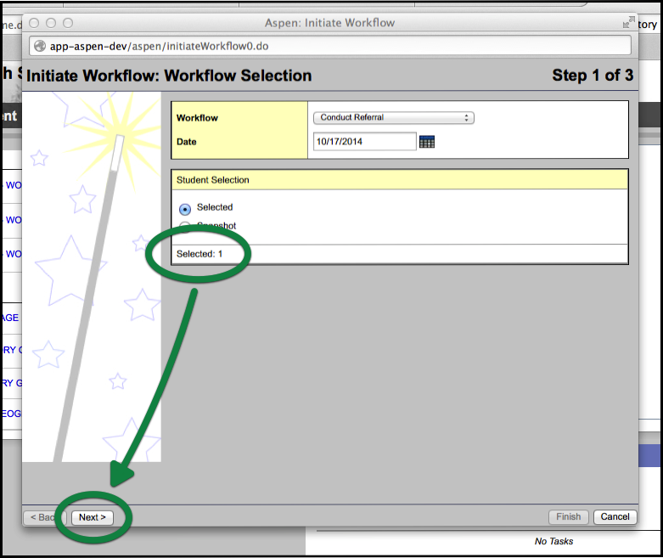

- In the next window make sure the Incident date and Incident time are correct. Click the Incident code pop-up and you can see what each code means by hovering over it with the mouse pointer.
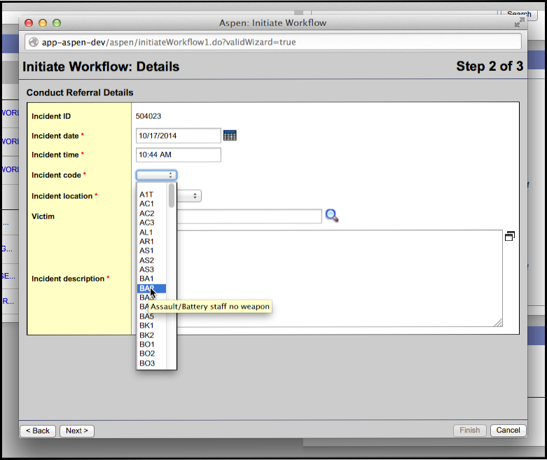

- Choose the Incident location from the pop up menu.
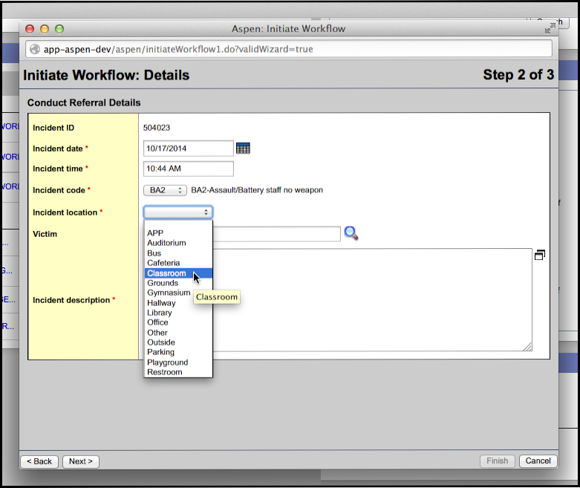

- If there is a victim, click on the magnifier icon and choose the victim the same way you chose the offender. Type a description of the incident in the Incident description field. Click Next.
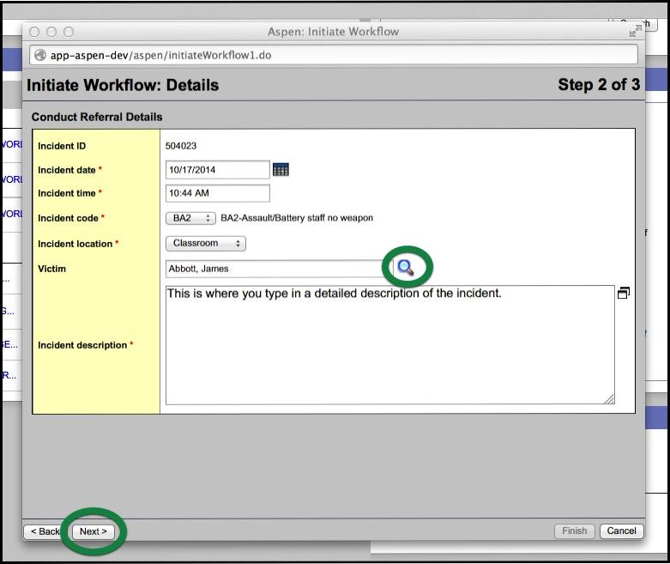

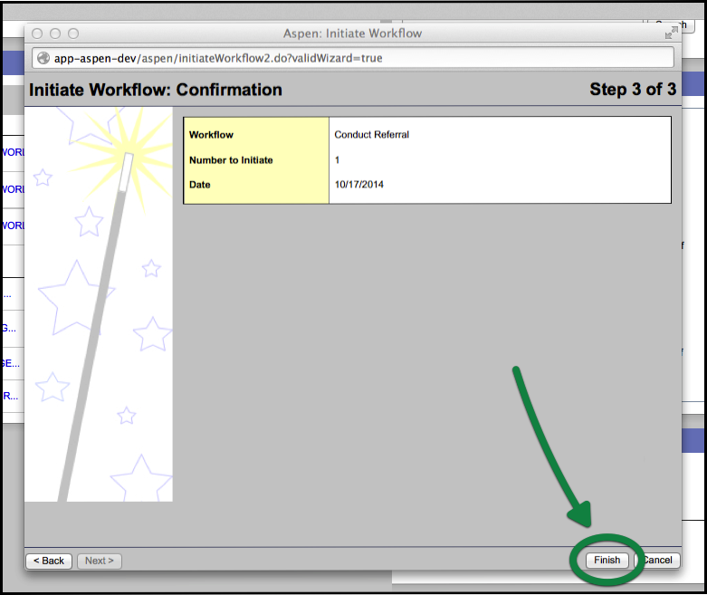
- On the last screen click Finish. You’re done!

